Agenda-To show the profit of the products for the Sales for a product

Create a sub report

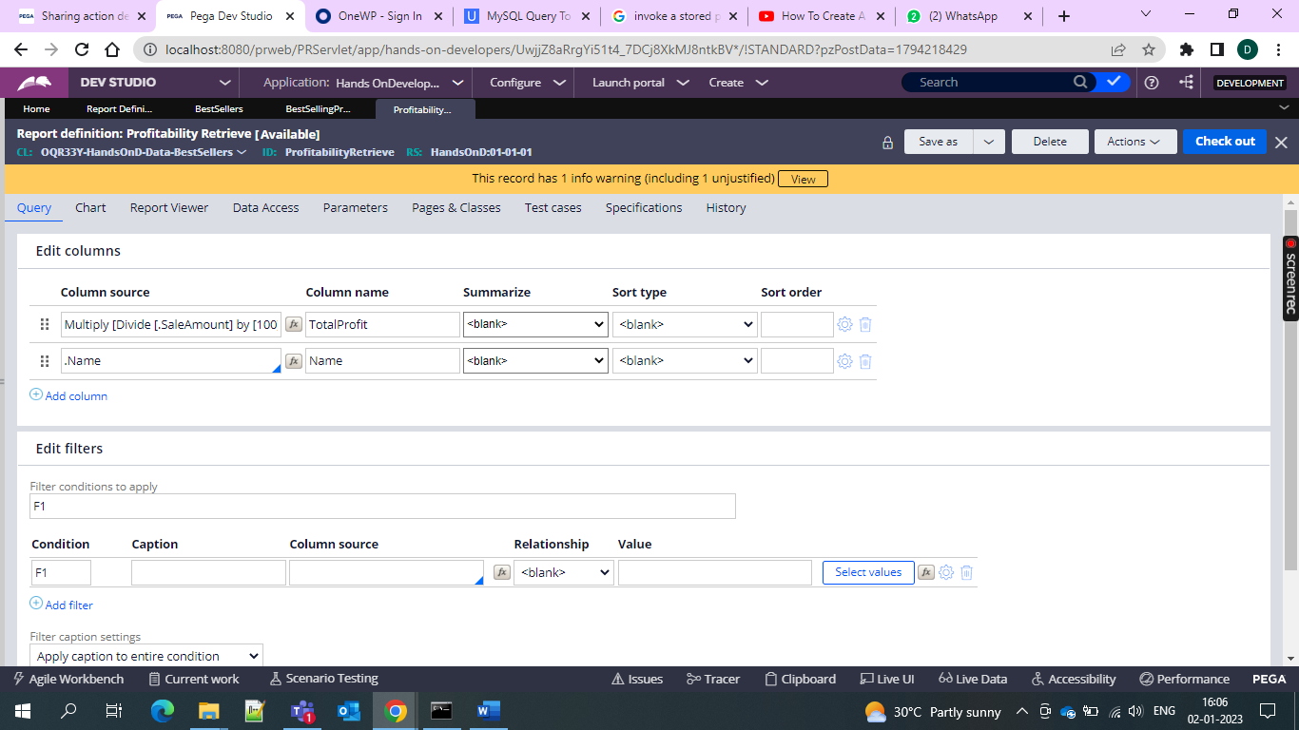

And use the multiply and divide functions to get the percentage

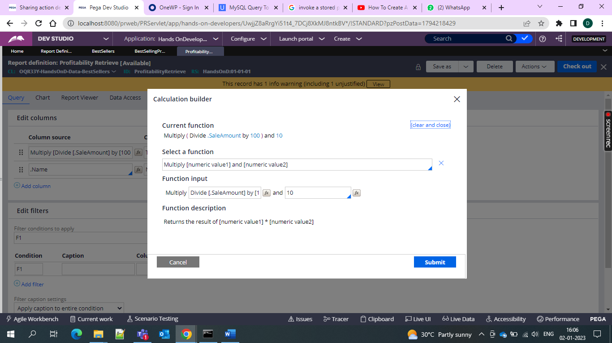

And then go for the adding of the sub report in the main report

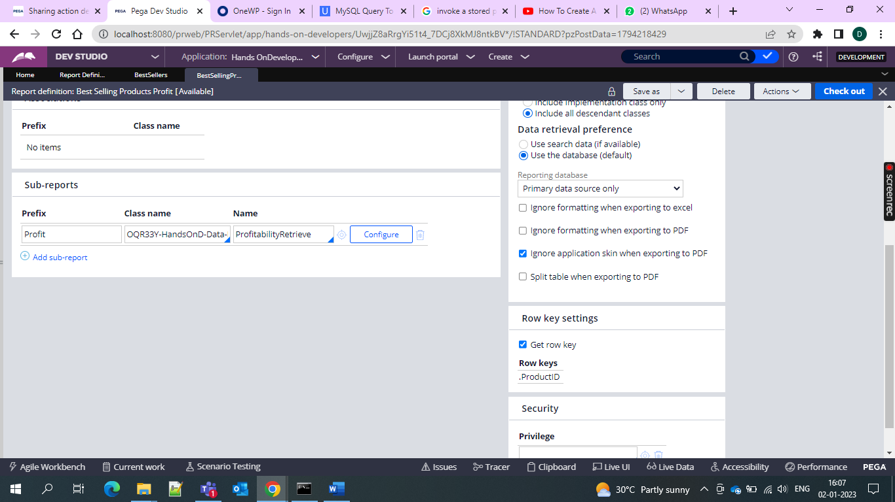

And 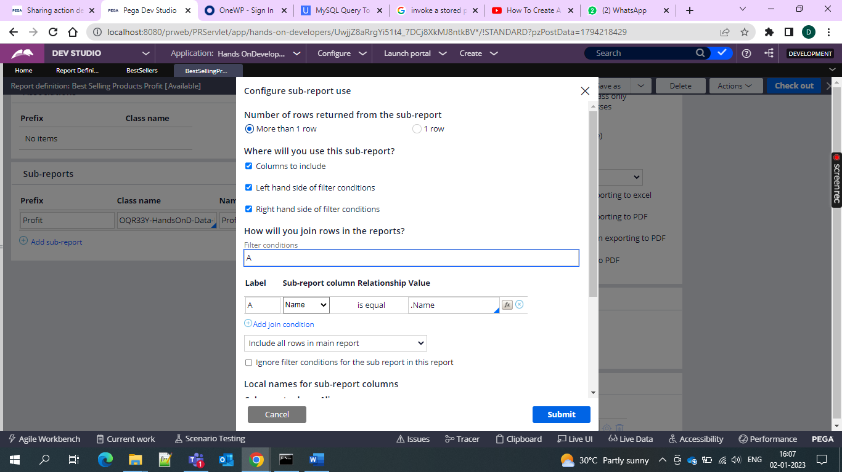

And hence percentage of the products

